**Sensor Attendance**

**SUBMITTED BY:**

**P S PRANEETH**

**Abstract**

**Introduction**

**Design Survey**

**Existing Designs and Advantage**

**New Design and Development**

**Modality, Sensing modes and parameters of Application**

**Conclusion**

**References & Tools**

## ABSTRACT

During capturing of attendance in classroom through the manual process. Most of the students try to give proxy attendance to their besties and competing classmates without their presence. At this time teacher cannot focus each and every student to verify their presence in class. This mainly leads a problem to faculty and often students as they miss their syllabus of particular subject. So Class Attendance Management can overcome this problem.

## INTRODUCTION

It works on sensor basis machine when student enters the class it detects them and give attendance partially to their presence, after faculty enters the partially gets locked then she can modify if necessary. Here signals from student_ID card will be received by sensor which mark attendance for that particular class. When entering and exiting class sensor receives signal from faculty_ID where it lock partially and totally. Modification of attendance done during class period.

## DESIGN SURVEY

According to survey we got so much valuable feedback from users like Teachers. This are the feedbacks given from them

1. Blink when attendance is registered
2. Message to be sent to student after registered
3. Fingerprint as optional if system is not working
4. If Student leaves/escapes before class completion attendance should be cancelled
5. Face recognition can be added as extra feature
6. Automated door to lock after faculty entered
7. Id card should be notified even in any posture
8. Fingerprint to be as optional
9. Work even without electricity by storing in battery
10. If sensors not working message to be sent to technical department for resolving.

## Existing Designs and Advantage

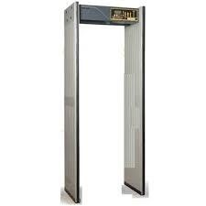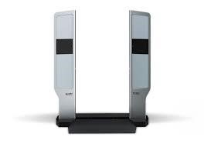

**FIG 1: Exiting product**

**ADVANTAGES OF DESIGN:**

1. Reduces admin work by capturing into database
2. Manual work for data retrieving is less
3. Easy access for students as well teachers
4. Time saving process
5. Error less and it doesn’t takes place mostly
6. Eliminates automatically the duplicate entry
7. Auto generation of attendance reports
8. Message will be sent to parents about attendance
9. Notifies student if debarred
10. Organizes attendance updated

**Modality, Sensing modes and parameters of Application**

|  |  |  |  |
| --- | --- | --- | --- |
| **Input**  **Modalities** | **Output**  **Modalities** | **Sensing Modes** | **Parameters** |
| Radio frequency Identifier | Digital display | Visual: Can see the attendance status by color | Enrolment |
| Barcode Scanner | Indicator  Lamp(to describe the status) | Tactile: Fingerprint recognition | Failure to capture and Failure to enroll  Detection Error  Rate |
| Button(Switch on or off) | User’s and admin’s device to check the attendance | Haptic: Buttons to operate the system | Verification and  Identification |
| Fingerprint, Finger vein(Additional) | Multifunctional display | Barcode recognition | Authentication |

## Conclusion

Our main aim to reduce error in daily attendance, effort of teacher, time of them. This product will make teacher easily to make attendance without error and without knowingly attendance is done. The only part is teacher must just verify it.

**REFERENCE TOOLS:**

1. Library sensory
2. Google Images
3. VIT student login